Software Design 2.0

Data Management Strategy

Data management is a very important aspect of our application. This app is not just one storefront or handling one type of user, we are handling different types of users that all have their unique properties and sensitive information. We must handle this information with care to not lose customers or our business partners. There also needs to be certain connections between these users and only certain information should be shared. For these reasons, our application will consist of 6 different databases to ensure security and organization: customers, drivers, businesses, nutrition, orders, and charities.

For our data management, we will be using SQL. Since our databases are relational, we believe this would be the most appropriate database management system. SQL allows us to ensure security and data integrity within our databases which follows the ACID model. This ensures all transactions must either be completed successfully or it will fail. Also, transactions are independent from each other which prevents a concurrent transaction from altering another one. SQL allows every transaction to be final which prevents any roll-backs from occurring even when a system failure takes place. SQL also supports dynamic and complex queries which we could benefit from should any changes need to be made and syntax is consistent regardless of the interface we use. It is worth noting that it can be expensive to scale and could potentially be a challenge to do so. However, we believe this trade-off is justified due to the nature of SQL’s security and privacy protection features along with the flexibility it provides.

Customer Database

The database is responsible for keeping track of customer accounts. This database must be well-secured as this contains very sensitive information. Some of the possible pieces of data stored are username, email, and phone number. A unique user ID will be created and stored in the data for internal identification purposes. Only information needed to contact and identify a user will be needed to store. Credit card information, address, and such data will not need to be saved for privacy purposes.

* can use the business database to look up locations
* No access to driver database, only needs to know their current driver
* No access to other customers
* Can access the nutritional database for nutrition information
* No access to the order database
* Access to charity database to see available ones

Driver Database

A Driver database is necessary so we can keep track of all employed drivers. Not only will this be used for tax purposes but for safety purposes to avoid imposters. We will keep track of an employee identification number, name, car license plate, email, bank information, and pay information.

* Access to the business database to know where to go
* Access to the order database to know what to pick up
* Only access the customer name and address to deliver
* No access to other drivers
* No need to access the nutritional database
* No need to access charities

Business Database

To keep our app functional, we need participating restaurants and stores that are willing to sell their leftover product. The database is necessary to know which businesses are in our system. Information stored includes business name, type of business, city, and address.

* Access to the customer database to see the name of the order
* Access to driver database to verify and give order to
* Access to the order database to keep track in case of anything
* Access to nutrition database to fill in information if applicable
* No access to other businesses
* No access to charities

Nutrition Database

One of our main goals is to promote sustainability and a healthy lifestyle so, we will be providing a database of nutritional information that participating restaurants can assist in completing. In this database, we will be storing documents provided by the companies that led to the nutritional information of their respective establishment.

* Is available to be viewed by customers
* Businesses contribute to this database
* No need for drivers to view
* No need to access itself
* No need to view orders
* No need to view charities

Orders Database

This database will be a bit more dynamic. We will not keep a record of every order ever made on the app but we will keep recent orders up to a certain amount of time. This will be important in case of any issues regarding cancellation, wrong order, or unsatisfactory experience. Information stored includes an order number, what restaurant it came from, and the order contents document.

* Customers can view orders
* Businesses add orders to the database
* Drivers view orders if necessary
* Orders link to nutritional information
* No access to itself
* No need to view charities

Charities Database

Though more different than our standard operations, working with reputable charities will be a great way to encourage community engagement. They are not included in the business database as methods of operation are a bit different. Name, money goal, money received, and number of donors are some stored aspects.

* Customers see the different charities and can choose to donate
* Can partner with restaurants to achieve goals faster
* No access to the driver database
* No access to orders
* No access to the nutrition database
* Can team up with other charities

SQL Diagram:

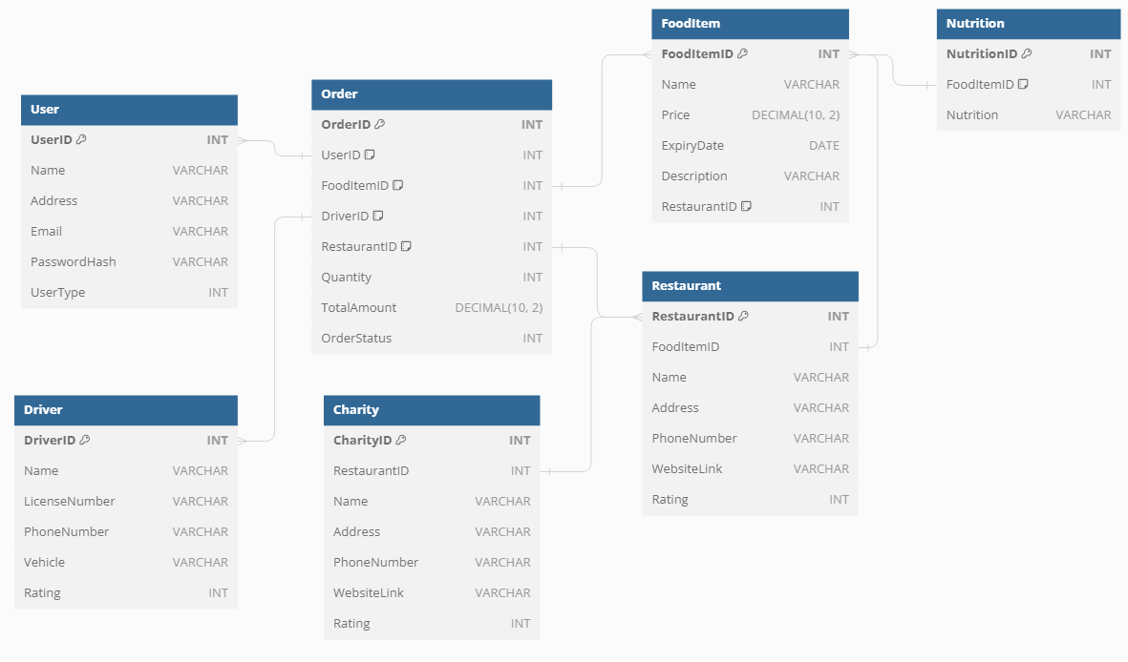

Architecture Diagram: